Academic Year: 2025-26 | Year: Second Year | Semester: II
PRN No.: 1012411011 | Name: Riddhee Kulkarni
Subject: Python Programming
Assignment No.: 12
Date: 12/01/2026

Lab Assignment: 12
Aim:
Write a program to sum the series -1+1/2+......1/n.

Objective:
• To understand the use of loop for series calculation.
• To perform division and addition operations in Python.
• To calculate the sum of a mathematical series.

Theory:
A series is a sequence of numbers added together.
In this program, the first term is −1 and the remaining terms are fractions from 1/2 up to 1/n.
A loop is used to add each term of the series one by one and store the result in a variable.

Algorithm:
- Start
- Read the value of n
- Initialize sum = -1
- Print -1
- Repeat for i from 2 to n
  - Print + 1/i
  - Add 1/i to sum
- Print the final value of sum
- Stop

Pseudo Code:
START
READ n
sum = -1
PRINT "-1"
FOR i = 2 TO n
PRINT "+ 1/i"
sum = sum + (1 / i)
END FOR
PRINT sum
STOP

Code:
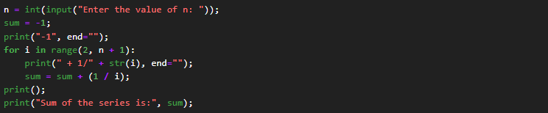

Output:

Conclusion:
The program correctly calculates the sum of the series −1 + 1/2 + 1/3 + … + 1/n using a simple loop.

